**Characterization of a capacitor and inductor**

**Capacitor**

-Picture

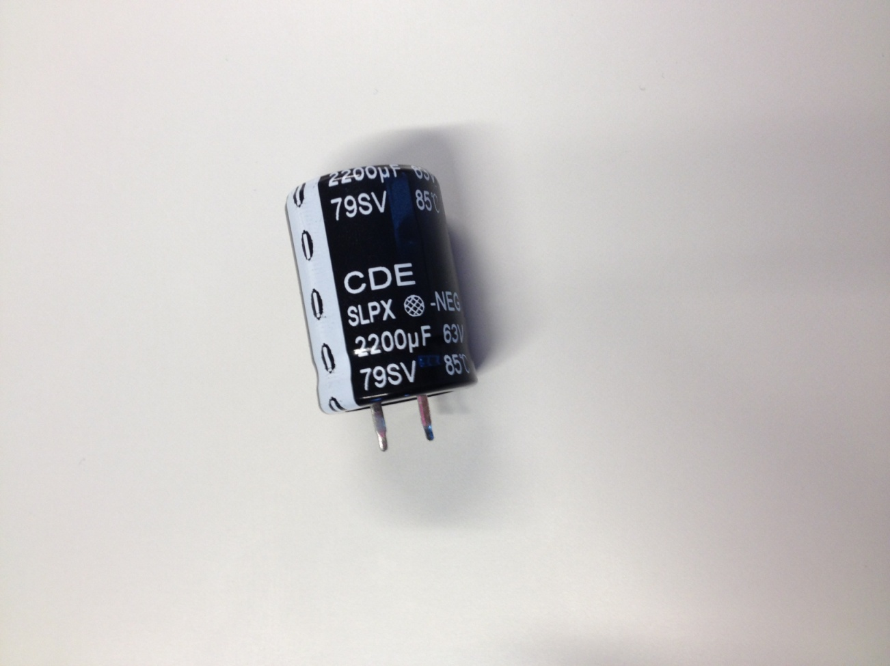

- Electrical model circuit



- Measured model parameters

At low frequencies the effect of the capacitance dominates:

At the resonant frequency ( the effect of the inductance and capacitance compensate and the gain is the resistance:

- Plot of impedance

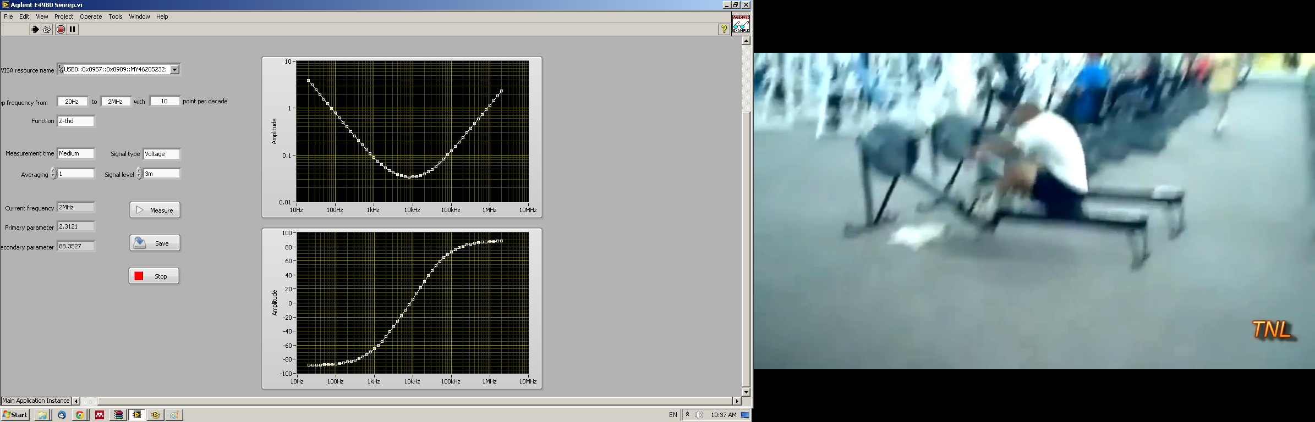

**Inductor**

-Picture

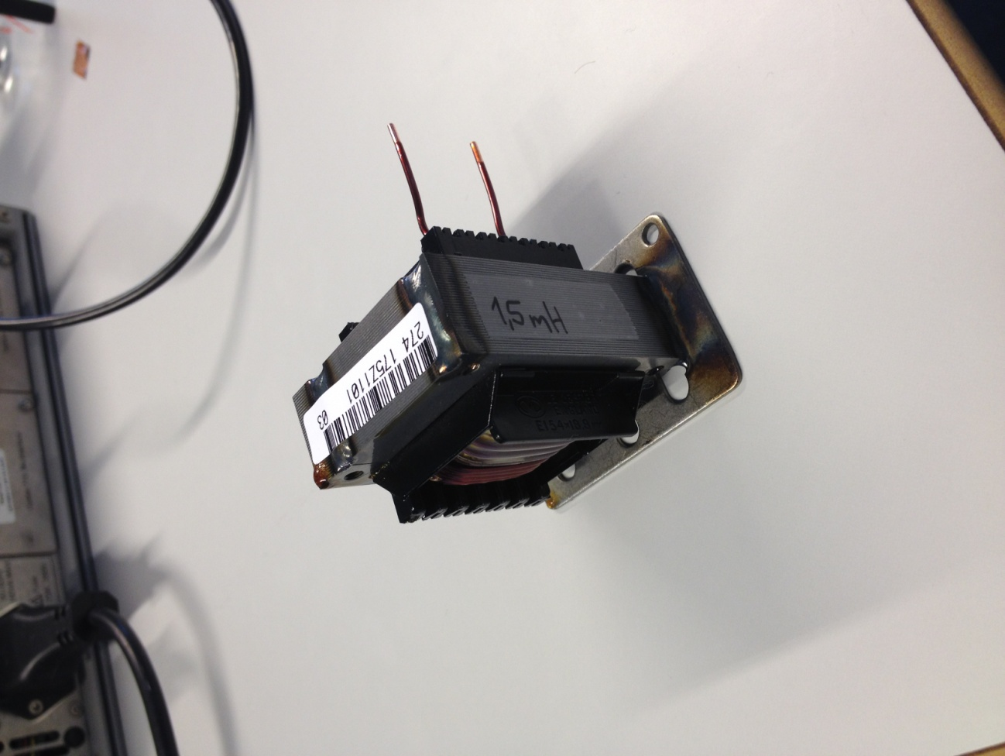

- Electrical model circuit

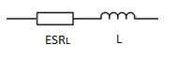

- Measured model parameters

With a phase angle of 90º (low frequencies) the effect of the inductance dominates:

For calculating the resistance we use 20Hz which is the lowest frequency measured (the ideal measurement would be with DC)

- Plot of impedance

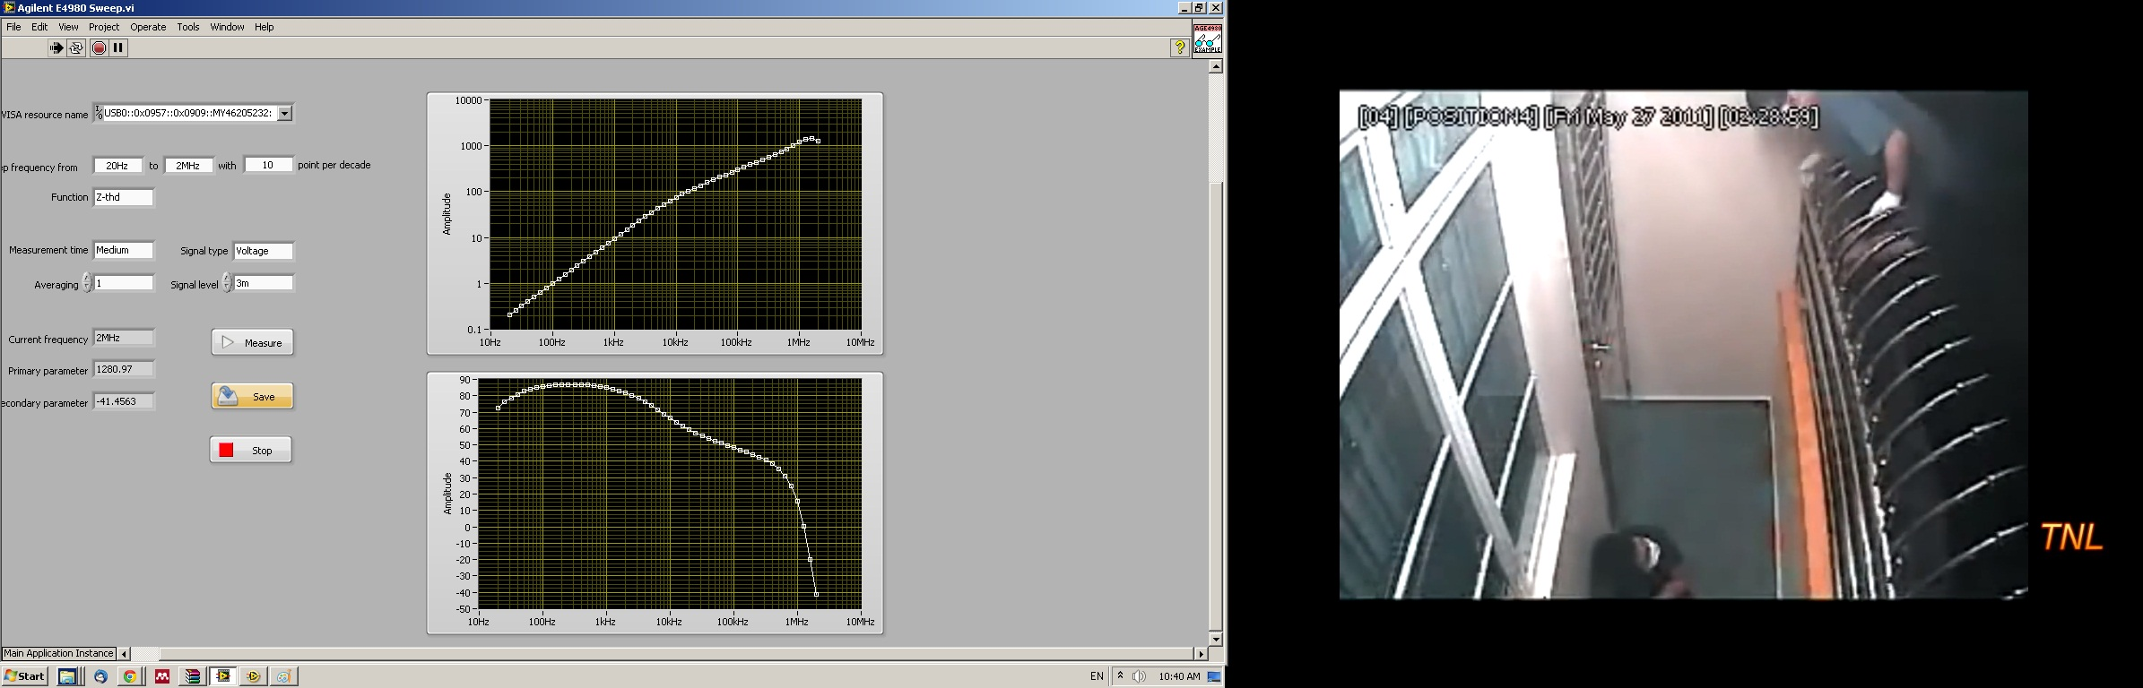

Type of instrument used for the measurements:

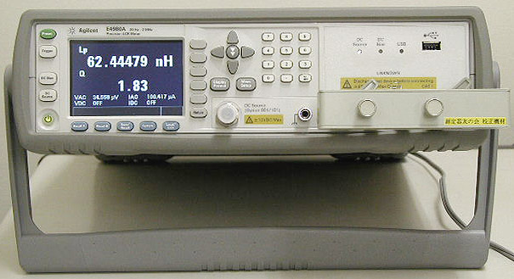

Agilent E4980A